DONIPHAN COUNTY RESOLUTION NO. 2015-03

A RESOLUTION PERTAINING TO OPEN BURNING OF PASTURE, TILLABLE FARM GROUND, CONSERVATION RESERVE PROGRAM LAND, WATER WAYS, RIGHTS-OF-WAYS, AND OTHER LAND.
WHEREAS, the grass and cropland of Kansas forms an important part of our economy and provides for the protection of watersheds, forage for livestock, refuge for wildlife and recreational opportunities. Wildfires endanger those resources, real and personal property, and the lives of residents and visitors in these areas; and,
WHEREAS, dry and windy weather conditions and above normal temperatures, combined with open public burning without consulting local fire departments sometimes creates a fire hazard to the grass and crop land of Doniphan County, Kansas; and,
WHEREAS, once started, these fires are often difficult to control. Out of control fire impacts the resources of rural fire districts not only financially, but in manpower as well.
WHEREAS, the damage caused by out-of-control fires can be minimized by requiring the public to notify the proper authorities of their intent to conduct open burning of pasture, stubble ground, conservation reserve program land, water ways, rights-of-way, and other land.
NOW, THEREFORE, THE BOARD OF COMMISSIONERS, DONIPHAN COUNTY, KANSAS DO HEREBY RESOLVE AS FOLLOWS:
- OPEN FIRE is any fire that is not started in a non-combustible container.
- REGULATIONS AND REQUIREMENTS
  - For fields, including CRP, rangeland, brush piles, large hay bales, structures, storm damage debris and lawns, the individual shall notify the Doniphan County Dispatcher at 785-985-3711 that he or she intends to do an open burn and provide the location of the intended burn, including the nearest crossroads. Upon receiving this notification, the dispatcher shall notify the Rural Fire District where the intended burn will take place. The individual shall notify the Doniphan County Dispatcher upon said fire being extinguished.
  - No open burning shall be set if the wind speed is to reach a velocity of more than 15 miles per hour.
  - All open burning shall be attended by the individual until the fire is extinguished.
  - No open burning shall be permitted after sunset.
  - The individual setting the open burn assumes responsibility for any fire damage that may result from said fire to neighboring property.
No open burn shall be set without proper firebreak (mowing, tilling, or plowing) around the area to be burned.
g. This resolution shall not be construed to authorize the burning of any material that would otherwise not be allowed by State or Federal law.
- EXCEPTION
No open burning will be allowed whenever a burn ban is in effect. The Emergency Management Coordinator is hereby authorized to issue a burn ban prohibiting all open burning within the County whenever conditions become so severe due to drought, wind, natural or man-made disasters or for security reasons as to constitute a serious danger to persons and/or property within the County. Such authorization shall become effective upon notice to the general public by any or all of the following methods: written notification to the County Dispatch, written publication in the Official newspaper, written notice on the County's official website and/or announcements through local media outlets and the county Textcaster site. The burn ban on open burning shall be removed once the Emergency Management Coordinator determines that the conditions causing the ban to be implemented have been sufficiently alleviated so as to no longer constitute a serious danger to the general public.
- PENALTIES AND FEES
Doniphan County is authorized to seek civil penalty against any person(s) violating the terms of this resolution in the sum of not less than $100.00 for a first violation and up to $500.00 for any subsequent violations. In addition, persons violating the terms of this resolution shall be responsible for any costs incurred by the County or a Rural Fire District on account of such violation.
- Doniphan County or any entity of Doniphan County shall not be responsible for damage done to individual property or neighboring property as a result of an open burn.
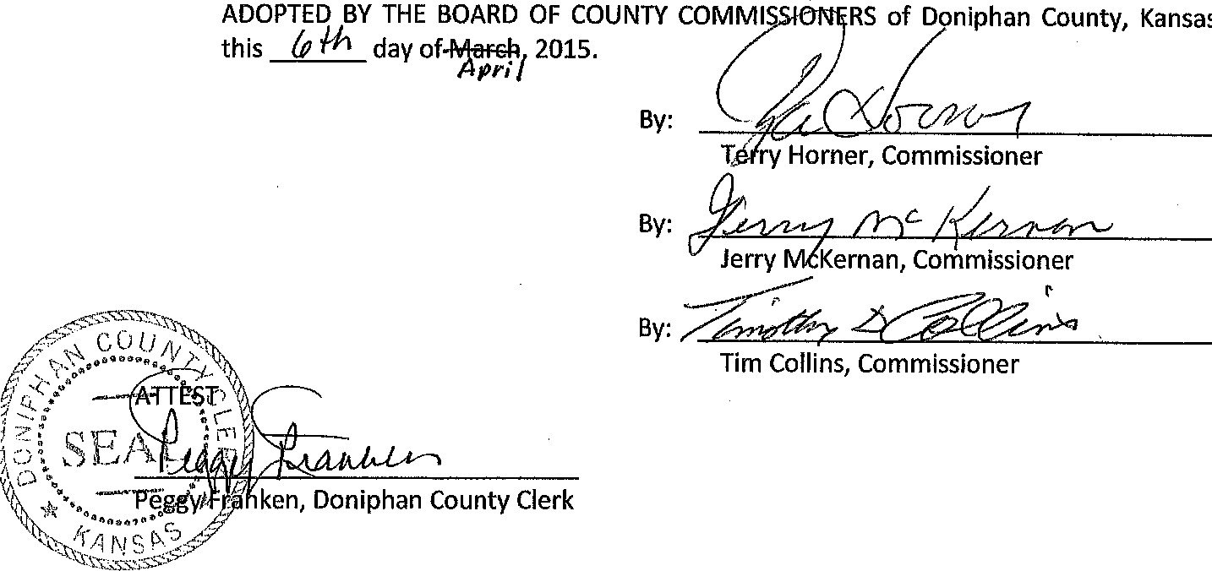
- This resolution shall be in effect from its adoption and publication once in the official county newspaper.

ADOPTED BY THE BOARD OF COUNTY COMMI this day 2015.
By:

